















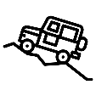



Sliders and Levers:
Moving Postcards
Monitoring and Control:

Fitbits
Frame Structures:
Anderson Shelters

Electrical Systems:
Buzzer Game
Pneumatics:
Moving Creatures
Levers and Linkages:
Christmas Cards
Free-standing Structures:
Castles
Cooking:
Ice Lollies
Cooking:

Jamaican Flavours
KS1 A
6
KS2 C
KS2 B
KS2 A
KS1 B

